AAI-540 Group 4 Design Document

Team Info
Project Team Group #: 4
Authors: Aliaksei Matsarksi, Birendra Khimding, Spencer Cody
Business Name: Standard Medical Models
Publication Date: June 2026

Team Workflows
GitHub Project Link: https://github.com/AAI-540-02-Group-4/FinalProject
Asana Board Link: https://app.asana.com/1/952672460738672/project/1214727047689503/board/1214727053000060
Team Tracker Link: https://docs.google.com/document/d/1-MnR35t2eCYYvlC173_CkU_Y-UdkMnVPRZ1CotBe0kg/edit?usp=sharing

Project Scope
Project Background:

1-2 paragraphs describing, at a high level, the problem you are trying to solve. This should provide the reader context for the technical solution they will review. This should be a quick elevator pitch for your project. Be sure to answer the following:
- What is the model’s objective?
- What type of Machine Learning problem will you be solving?

The goal of this project is to develop a machine learning image analysis algorithm that can detect pneumonia in chest x-ray images of patients. The model will serve to assist doctors in properly detecting pneumonia from X-ray images. This will lead to quicker and more accurate diagnosis, thus resulting in patients getting the care they need faster. The type of model being built for this task will be an image-based binary classification model.

Technical Background:
The key metrics to assess the success of the model will be accuracy, precision, recall (sensitivity), specificity, and F1-score. Since this model will be used in assisting in medical diagnosis, it is critical that it is quite accurate. False positives or false negatives could have dire results for a patient.
This project combines two data sources. The first dataset is the Chest X-Ray Images (Pneumonia), which consists of 5,863 chest X-ray images labeled as either normal or pneumonia. The second dataset is the RSNA Pneumonia Detection Challenge dataset. It contains 29,700 chest x-ray image files with 10 columns of data, including a binary target label indicating pneumonia or non-pneumonia. The primary data exploration for this project will be to understand the distribution of true and false. Since it is an image-based classification problem, feature analysis or engineering is not very necessary; image preprocessing will be. This dataset has been initially screened for low-quality images, however for future x-ray images an image quality metric should be developed.
For any image classification problem, we foresee using a convolutional neural network (CNN) as the model I’d want to develop and use.
For this project, we intend to use a convolutional neural network to classify the images. CNNs excel at developing image models, so they will be appropriate for this task.

Goals vs Non-Goals:
- Goal: The most accurate model possible, while considering the impacts of false positives vs false negatives.
- Goal: Robust image preprocessing to enhance image attributes and normalize images, thus improving the model’s accuracy and generalizability
- Goal: Develop an end-to-end pipeline that allows for easy integration of updated models and seamless retraining and evaluation
- Non-Goal: Active monitoring of model performance in real-time
- Non-Goal: Building a user interface for doctors to interact with the model.

Solution Overview

1-2 paragraphs summarizing your ML System. Include a system architecture diagram containing the components you use to store data, pre-process data, engineer features, build/train/debug your model, and deploy your model. Also, add notes on what you will monitor and what you will test prior to releasing a new model.

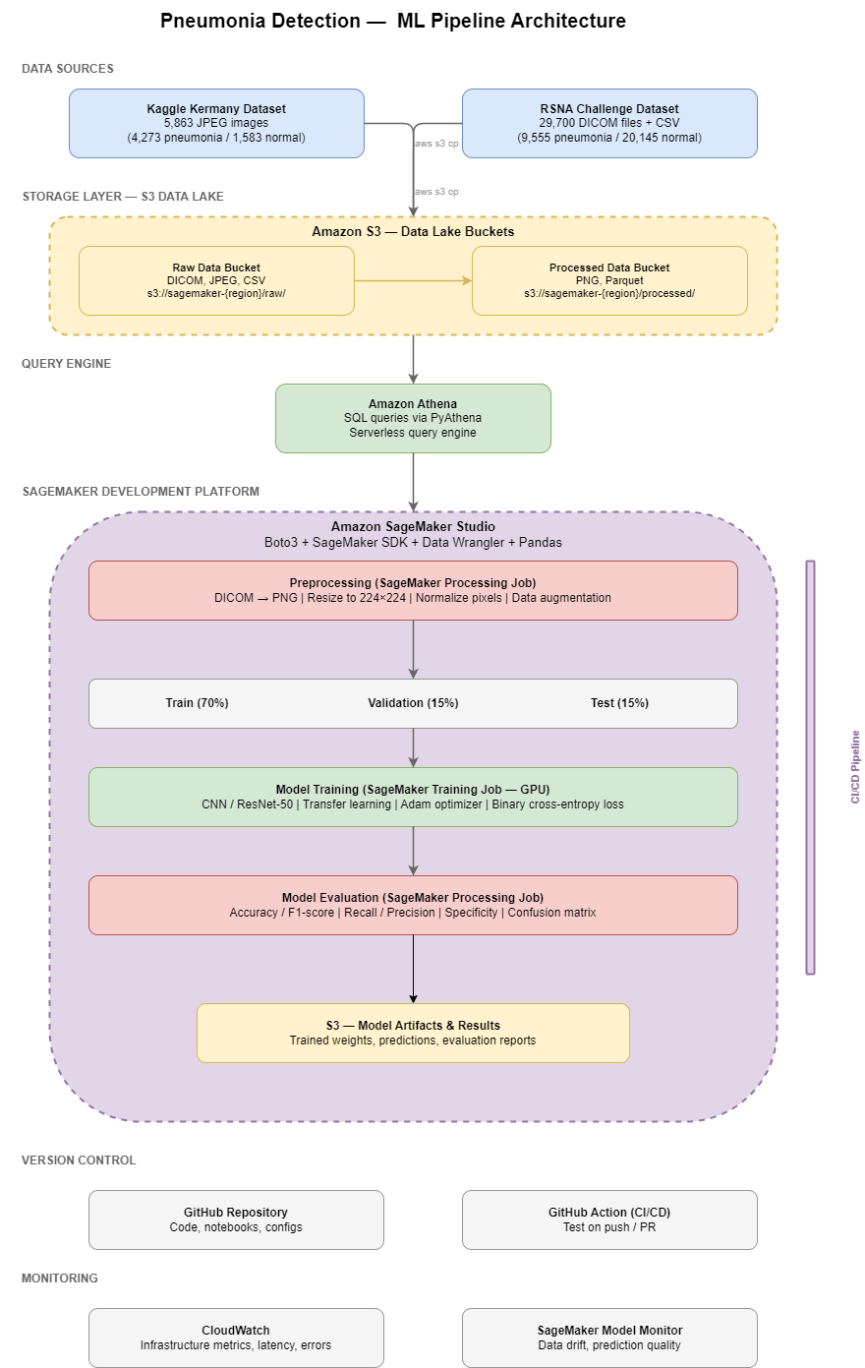

This system is a pneumonia detection pipeline built on AWS that takes chest x-ray images from two Kaggle datasets, stores them in an S3 data lake, and uses Athena to explore and query the data. Inside SageMaker Studio, the images are preprocessed by converting formats, resizing, and normalizing, then split into training, validation, and test sets to train a convolutional neural network. The model is evaluated on metrics like accuracy, recall, and F1-score to ensure it meets the standards needed for assisting in medical diagnosis.

All code and configurations are version-controlled in GitHub, with a CI/CD pipeline that automatically runs tests on every push to verify preprocessing and check for data leakage. Once deployed, CloudWatch monitors infrastructure health while SageMaker Model Monitor tracks data drift and prediction quality, alerting the team if the incoming x-rays start looking different from what the model was trained on and signaling that retraining may be needed.

Data Sources:

What is your data source?

Two Kaggle datasets, the Chest X-Ray Images (Pneumonia) dataset by Kermany et al. and the RSNA Pneumonia Detection Challenge dataset.

What is your data volume?

The Kaggle Kermany dataset contains 5,863 chest x-ray images in JPEG format, with 4,273 pneumonia and 1,583 normal. The RSNA dataset contains 29,700 chest x-ray image files in DICOM format with 10 columns of metadata, including approximately 9,555 pneumonia and 20,145 non-pneumonia images. Combined, the datasets provide roughly 13,828 pneumonia and 21,728 normal images.

Why did you select this data set?

These are the two most widely used and benchmarked chest X-ray pneumonia datasets. The Kermany dataset focuses on pediatric patients, while the RSNA dataset includes a broader patient population

Any risks (bias, sensitive features, etc)?

The Kaggle dataset only includes pediatric patients, while the RSNA dataset is more diverse but primarily comes from US institutions. Both datasets may underrepresent certain racial, ethnic, and age groups, meaning the model could perform differently across patient subgroups.

Data Engineering:

How will you store this data?

All data will be stored in Amazon S3 as part of a data lake architecture. Raw images and metadata CSVs will go into a raw data bucket organized by source dataset. After preprocessing, the converted and normalized images will be stored in a separate processed data bucket organized by class label.

What data pre-processing do you need to do before you feed it into your ML system?

The RSNA DICOM images need to be converted to PNG format since the Kaggle images are already in JPEG. All images will be resized to a consistent 224×224 pixel resolution to match the input requirements of standard CNN architectures. Pixel values will be normalized to a 0–1 range.

Training Data:

How will you split your data into training, test, and validation?
The combined dataset will be split into 70% training, 15% validation, and 15% test using stratified sampling to maintain class balance across all three splits.

Will you use any data labeling techniques?

No additional labeling is needed. Both datasets come pre-labeled by medical experts.

Feature Engineering:

Which fields from your data will you use or exclude?
Which fields will be combined or bucketed?
What other data transformations will you apply to your data?

Model Training & Evaluation:

How will you train your model?
What algorithm will you use?
What parameters will you use?
How will you evaluate your model?

Model Deployment:

What instance size will you use?
Will your model function as a batch or a real-time model? Why?

Model Monitoring:

How will you monitor your model?
How will you monitor your infrastructure?
How will you monitor your data?

Model CI/CD:
What checkpoints will your CI/CD pipeline contain?
What tests will your CI/CD pipeline contain?

Security Checklist, Privacy and Other Risks:

Will this store or process Personal Health Information (PHI)?
Will this store or process Personal Identifiable Information (PII)?
Will user behavior be tracked and stored?
Will this store or process credit card information?
If you answered yes to any of the above questions, please justify.
What S3 buckets will this application read from or write to?
What data bias should be considered?
Will your model have potential for bias along sensitive features (race, ethnicity, gender, age, religion, disability, sexual orientation, or other personal attributes)
Are there any ethical concerts with the data or business problems that should be addressed?

Future Enhancements:

Provide at least 3 ways you would improve your ML system if you had more time or additional resources.

